Calculus project

#include<iostream>

#include<math.h>

using namespace std;

int main()

{

string x;

cout<<":Check Domain And Range For This Program:"<<endl;

cout<<endl;

int domain;

float ans = 0;

bool run = true;

while(run)

{

cout<<"Please Enter The Number To check Domain : ";

cin>>x;

if(x=="end")

{

cout<<"Program is End";

cout<<endl;

run = false;

}

else

{

domain=stoi(x);

ans = (domain-1)/sqrt(pow(domain,2)-2);

if(domain==0 || domain==-1)

{

cout<<"The value of 0 does not lie in Domain:"<<endl;

cout<<endl;

}

else

{

cout<<"The Range is : "<<ans<<endl;

cout<<endl;

}

}

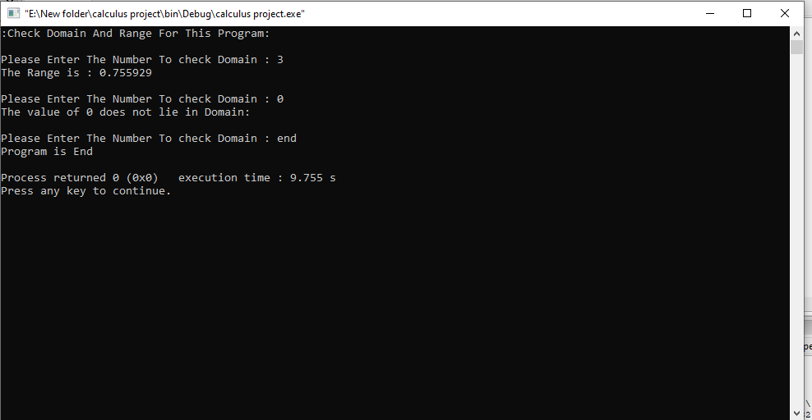

}

return 0;

}